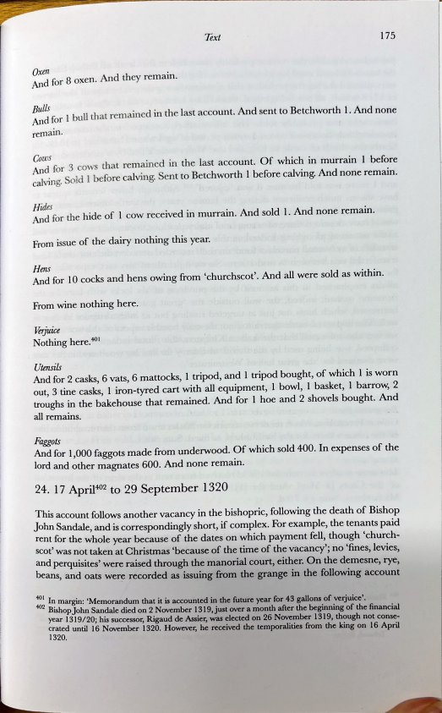
Text ¹⁷⁵
Oxen . And for 8 oxen. And they rema1n.
Bults
And for 1 bull that remained in the last account. And sent to Betchworth 1. And none remam.
::: for 3 cows that remained in the last account. Of which in murrain 1 before calving. Sold 1 bef ore calving. Sent to Betchworth 1 bef ore calving. And none remain.
Hules
And for the hide of I cow received in murrain. And sold 1. And none remain. From issue of the dairy nothing this year.
Hens
And for 10 cocks and hens owing from 'churchscot'. And all were sold as within. From wine nothing here.
Verjuice
Nothing here.4-0¹
Utmsils
And for 2 casks, 6 vats, 6 mattocks, 1 tripod, and 1 tripod bought, of which 1 is warn out, 3 tine casks, 1 iron-tyred cart with all equipment, 1 bowl, 1 basket, 1 barrow, 2 troughs in the bakehouse that remained. And for 1 hoe and 2 shovels bought. And all remains.
Faggots
And for 1,000 faggots made from underwood. Of which sold 400. In expenses of the lord and other magnates 600. And none remain.
24. 17 April⁴⁰² to 29 September 1320
This account follows another vacancy in the bishopric, following the death of Bishop John Sandale, and is correspondingly short, if complex. For example, the tenants paid rent for the whole year because of the dates on which payment fell, though 'church scot' was not taken at Christmas 'because of the time of the vacancy'; no 'fines, levies, and perquisites' were raised through the manorial court, either. On the demesne, rye, beans, and oats were recorded as issuing from the grange in the following account :; 1~ margin: 'Memorandum that it is accounted in the future year for 43 gallons of verjuice'.
BJShopJohn Sandale died on 2 November 1319,just over a month after the beginning of the financial year 1319/20; his successor, Rigaud de Assier, was elected on 26 November 1319, though not conse crated until 16 November 1320. However, he received the temporalities from the king on 16 April 1320.
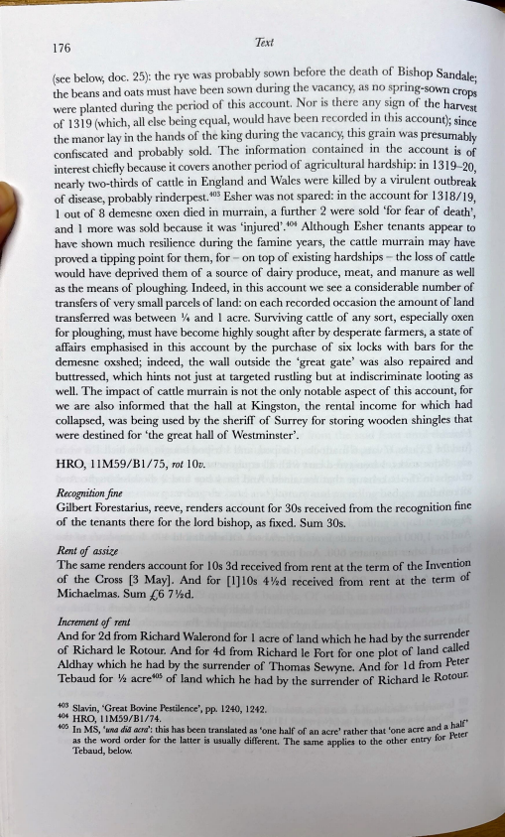
176 Text
(see below, doc. 25): the rye was probably sown before the death of Bishop Sandale· the beans and oats must have been sown during the vacancy, as no spring-sown crop' were planted during the period of this account. Nor is there a~y si~ of the harves: of 1319 (which, all else being equal, would have been recorded 111 th1s account); since the manor lay in the hands of the king during the vacancy, this grain was presumably confiscated and probably sold. The information contained in the account is of interest chiefly because it covers another period of agricultural hardship: in 1319-20, nearly two-thirds of cattle in England and Wales were killed by a virulent outbreak of disease, probably rinderpest.4-0³ Esher was not spared: in the account for 1318/19, 1 out of 8 demesne oxen died in murrain, a further 2 were sold 'for fear of death', and 1 more was sold because it was 'injured'.4-0⁴ Although Esher tenants appear to have shown much resilience during the famine years, the cattle murrain may have proved a tipping point for them, for - on top of existing hardships - the loss of cattle would have deprived them of a source of dairy produce, meat, and manure as weil as the means of ploughing. Indeed, in this account we see a considerable number of transfers of very small parcels of land: on each recorded occasion the amount of land transferred was between ¼ and 1 acre. Surviving cattle of any sort, especially oxen for ploughing, must have become highly sought after by desperate farmers, a state of affairs emphasised in this account by the purchase of six locks with bars for the demesne oxshed; indeed, the wall outside the 'great gate' was also repaired and
buttressed, which hints not just at targeted rustling but at indiscriminate looting as well. The impact of cattle murrain is not the only notable aspect of this account, for we are also informed that the hall at Kingston, the rental income for which had collapsed, was being used by the sheriff of Surrey for storing wooden shingles that were destined for 'the great hall of Westminster'.
HRO, l 1M59/Bl/75, rot IOv.
Recognition .fine
Gilbert Forestarius, reeve, renders account for 30s received from the recognition fine of the tenants there for the lord bishop, as fixed. Sum 30s.
Rent of assi,ze
The same renders account for 1 Os 3d received from rent at the term of the Invention of the Cross [3 May]. And for [l] 10s 4 ¹12d received from rent at the term of Michaelmas. Sum [,6 7 ½d.
Increment of rent
And for 2d from Richard Walerond for 1 acre of land which he bad by the surrender of Richard le Rotour. And for 4d from Richard le Fort for one plot of land called Aldhay which he bad by the surrender of Thomas Sewyne. And for I d from Peter Tebaud for ½ acre⁴⁰⁵ of land which he bad by the surrender of Richard le Rotour.
: Slavin, 'Great Bovine Pestilence', pp. 1240, 1242.
HRO, l IM59/Bl/74. f' 405 In MS, 'una diii acra': this has been translated as 'one half of an acre' rather that 'one acre and a hal as the word order for the latter is usually different. Thc samc applics to thc othcr cntry for Peter Tebaud, below.
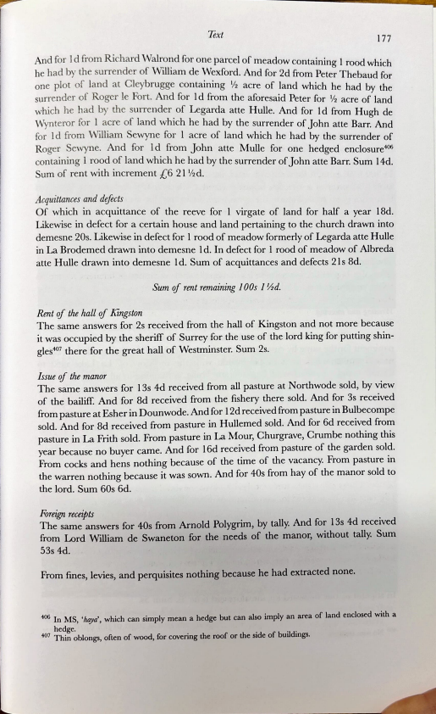
Text 177
And for 1 d from Richard Walr_o~d for one parcel of meadow containing l rood which he had by the surrender of William de Wexford. And for 2d from Peter Thebaud for one plot of land at Cleybrugge containing ½ acre of land which he had by the surrender of Roger le Fort. And for 1 d from the aforesaid Peter for 1;₂ acre of land which he ~ad by the surrender_of Legarda atte Hulle. And for ld from Hugh de W)mteror 1or 1 acre of land wh1ch he had by the surrender of John atte Barr. And for 1 d from William Sewyne for 1 acre of land which he had by the surrender of Roger Se,")me. And for 1 d from John atte Mulle for one hedged enclosure406 containing 1 rood of land which he had by the surrender of John atte Barr. Sum 14d. Sum of rent with increment -{,6 21 ½d.
AcquiUances and defects
Of which in acquittance of the reeve for 1 virgate of land for half a year 18d. Likewise in defect for a certain house and land pertaining to the church drawn into demesne 20s. Likewise in defect for 1 rood of meadow formerly of Legarda atte Hulle in La Brodemed drawn into demesne 1 d. In defect for 1 rood of meadow of Albreda atte Hulle drawn into demesne 1 d. Sum of acquittances and defects 21 s 8d.
Sum of rent remaining 1 00s 1 ½d.
Rent of the hall of Kingston
The same answers for 2s received from the hall of Kingston and not more because it was occupied by the sheriff of Surrey for the use of the lord king for putting shin gles⁴⁰⁷ there for the great hall of Westminster. Sum 2s.
Issue of the manor
The same answers for 13s 4d received from all pasture at Northwode sold, by view of the bailiff. And for 8d received from the fishery there sold. And for 3s received from pasture at Esher in Dounwode. And for 12d received from pasture in Bulbecompe sold. And for 8d received from pasture in Hullemed sold. And for 6d received from pasture in La Frith sold. From pasture in La Mour, Churgrave, Crumbe nothing this year because no buyer came. And for 16d received from pasture of the garden sold. From cocks and hens nothing because of the time of the vacancy. From pasture in the warren nothing because it was sown. And for 40s from hay of the manor sold to the lord. Sum 60s 6d.
Foreign receipts
The same answers for 40s from Arnold Polygrim, by tally. And for 13s 4d received from Lord William de Swaneton for the needs of the manor, without tally. Sum 53s 4d.
From fines, levies, and perquisites nothing because he had extracted none.
406 In MS, 'haya', which can simply mean a hedge but can also imply an area of land enclosed with a hedge. ₄₀₇ Thin oblongs, often of wood, for covering the roof or the side of buildings.
r
178
Sales at the audit
Text
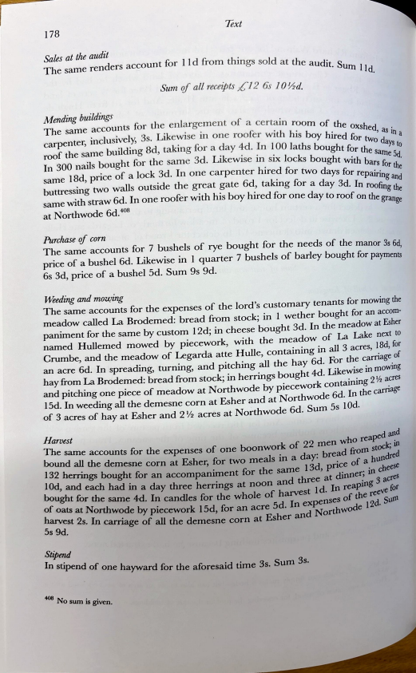
The same renders account for l ld from things sold at the a d"
u it. Surn I ld.
Sum ef all receipts L' 12 6s J O ½d.
Mending buildings
The same accounts for the enlargement of a certain room of th 3 Lik ^{. . fc . e oxshed}
carpenter, inclusively, s. ewise m one roo er w1th his boy hired fc , as in a roof the same building 8d, taking for a day 4·d. In l 00 laths bought fc or two days to fc h 3d Lik . . . or the sarn 5
In 300 nails bought or t e same . ewise 1n six locks bought with b e d. same I 8d, price of a lock 3d. In one carpenter hired for two days for a~s. for the . . repainng buttres~ing two walls outside the g:eat !sate 6d.' taking for a day 3d. In roofin a_{o}d same with straw 6d. In one roof er with h1s boy hrred for one day to roof on th g tbe
e grange
at Northwode 6d. ⁴⁰⁸
Purchase of corn
The same accounts for 7 bushels of rye bought for the needs of the manor 3s 6d
'
price of a bushel 6d. Likewise in l quarter 7 bushels of barley bought for payments 6s 3d, price of a bushel 5d. Sum 9s 9d.
~eding and mou;ing
The same accounts for the expenses of the Iord's customary tenants for mowing the meadow called La Brodemed: bread from stock; in l wether bought for an accom paniment for the same by custom 12d; in cheese bought 3d. In the meadow at Esher named Hullemed mowed by piecework, with the meadow of La Lake next to Crumbe, and the meadow of Legarda atte Hulle, containing in all 3 acres, 18d, for an acre 6d. In spreading, turning, and pitching all the hay 6d. For the carriage_ of
• • • owmg
hay from La Brodemed: bread from stock; in herrings bought 4d. Likewise m m d . h" . . k t 'ning 2½ acres
an p1tc 1ng one p1ece of meadow at Northwode by p1ecewor con ai . 15d. In weeding all the demesne corn at Esher and at N orthwode 6d. In the carnage of 3 acres of hay at Esher and 2 ½ acres at N orthwode 6d. Sum 5s 1 Od. dand
Harvest
The same accounts for the expenses of one boonwork of 22 men who rea~ _.,. in
b d from ^{st}~'
ound all the demesne corn at Esher. for two meals in a day: rea h ncfred
b
• ' • e of a u
l 32 hernngs bought for an accompaniment for the same 13d, pnc • cheese 1 Od, and each had in a day three herrings at noon and three at dinner; 1fl 3 acres bought for the same 4d. In candles for the whole of harvest 1 d. In rea:;:n~eve for
0
of oats at Northwode by piecework 15d for an acre 5d. In expenses
!ci el 2d. SUfJl
ha.rve_{S}t 2s. In carriage of all the demes~e corn at Esher and Nor^{th}w e 5s 9d.
Stipend
In st^{i}pend of one hayward for the aforesaid time 3s. Sum 3s. 408 N . ₀ sum 1S given.
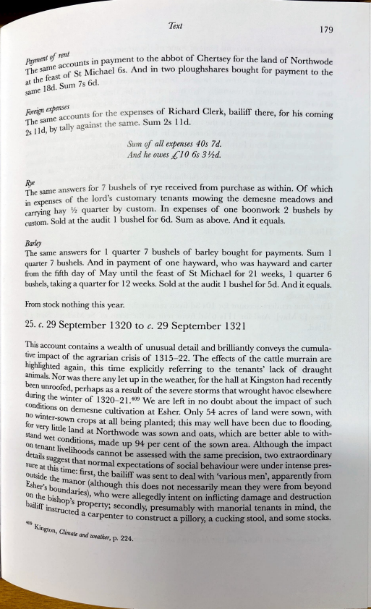
Text ₁₇₉
oavrnent of rent t in payrnent to the abbot of Chertsey for the land of Northwode _{i i::, accoun s . 1 h h} fhe sarne St Michael 6s. And m two p oug s ares bought for payment to the _{th [east of} at e 8d Sum 7s 6d.
sarne 1 •
foreign expenses ts for the expenses of Richard Clerk, bailiff there, for his coming e accoun fhe sarn all ainst the same. Sum 2s 11 d. 2s Il d, by t y ag
Swn of all expenses 40s 7d.
And he owes L' 10 6s 3 ½d.
Rye answers for 7 bushels of rye received from purchase as within. Of which _{The same .} nses of the lord's customary tenants mowing the demesne meadows and _{in expe} •ng hay ½ quarter by custom. In expenses of one boonwork 2 bushels by :;m. Sold at the audit 1 bushel for 6d. Sum as above. And it equals.
Barky
The same answers for 1 quarter 7 bushels of barley bought for payments. Sum 1 quarter 7 bushels. And in payment of one hayward, who was hayward and carter from the fifth day of May until the feast of St Michael for 21 weeks, 1 quarter 6 bushels, taking a quarter f or 12 weeks. Sold at the audit 1 bushel f or 5d. And it equals.
From stock nothing this year.
25. c. 29 September 1320 to c. 29 September 1321
This account contains a wealth of unusual detail and brilliantly conveys the cumula tive impact of the agrarian crisis of 1315-22. The effects of the cattle murrain are hi~hlighted again, this time explicitly referring to the tenants' lack of draught anunals. Nor was there any let up in the weather, for the hall at Kingston had recently ~e? unroofed, perhaps as a result of the severe storms that wrought havoc elsewhere
unng ^{th}e winter of 1320-21.4-0⁹ We are left in no doubt about the impact of such conditions n on d I • • f 1 d ·th . emesne cu tlvatlon at Esher. Only 54 acres o an were sown, w1 fo~ Wlnte~-sown crops at all being planted; this may well have been due to flooding, very httle 1 d N . • stand an at orthwode was sown and oats, wh1ch are better able to with- Wet cond·t' • _{on tenan r .}
1 1⁰ns, made up 94 per cent of the sown area. Although the rmpact details t ivelihoods cannot be assessed with the same precision, two extraordinary sure at :~?g~st t^{h}at normal expectations of social behaviour were under intense pres- ₁₈ outside time· first th b il' • • tl fi th • , e a 1ff was sent to deal with 'vanous men', apparen y rom Esher's b e mdan?r (although this does not necessarily mean they were from beyond oun aries) h ₀ . n the bish , ' w ^{O} were allegeclly intent on inflicting damage and destruction bailiff instrop ⁸ property; secondly, presumably with manorial tenants in mind, the _{ucted a}
carpenter to construct a pillory, a cucking stool, and some stocks. 409
l<ington Cf
' zmate and weather, p. 224.

